**To build a simple form using Yii2 & PHP**

**Step-1:**

* Installed Yii, Composer, PHP7 (followed MVC methodology)
* Used [www.yiiframework.com](http://www.yiiframework.com) to understand the framework and how to work with it
* Configured browser to change proxy settings to allow localhost at 8080
* Started the server using Command Line on the “Basic” directory- > yii serve
* Used the existing sample application to understand the front end and backend
* <https://localhost:8080/index.php> got me to test web application

**Step-2:**

* Tested “Hello World” by sending a message via URL.
* Created an Action to call the view

ACTION object “actionSay” to call the view “say” when “message” is sent

public function actionSay($message = 'Hello')

{

return $this->render('say', ['message' => $message]);

}

**Note:** This function code was appended to predefined code in SiteController where class pre-exists for other objects belonging to other pages

VIEW definition defined in site.php

<?php

use yii\helpers\Html;

?>

<header > <i> <font size="10" color="red" face="Courier New" >

<?= Html::encode($message)?>

</font> </i> </header>

<p1> <font size="5" color="blue" face="Courier New" > <b> Note: </b> This Message Was Sent To Me By You! </font> </p1>

URL used to display the message: <http://localhost:8080/index.php?r=site%2Fsay&message=Hello+World>

Output:

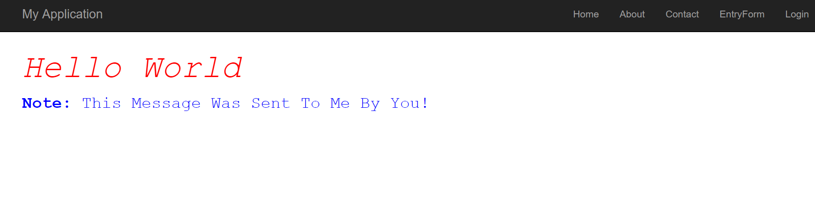

**Step-3:** To build a simple form (parent model is not associated with database unlike ActiverRecord)

* Created a new model – EntryFrom to link the form input elements

<?php

namespace app\models;

use Yii;

use yii\base\Model;

class EntryForm extends Model

{

public $name;

public $email;

public function rules()

{

return [

[['name', 'email'], 'required'],

['email', 'email'],

];

}

}

* Created a new Action method under SiteController.php

public function actionEntry()

{

$model = new EntryForm();

if ($model->load(Yii::$app->request->post()) ) {

return $this->render('entry-confirm', ['model' => $model]);

} else {

return $this->render('entry', ['model' => $model]);

}

}

* Create View “entry.php” – to create and display the form

<?php

use yii\helpers\Html;

use yii\widgets\ActiveForm;

?>

<?php $form = ActiveForm::begin(); ?>

<?= $form->field($model, 'name') ?>

<?= $form->field($model, 'email') ?>

<div class="form-group">

<?= Html::submitButton('Submit', ['class' => 'btn btn-primary']) ?>

</div>

<?php ActiveForm::end(); ?>

* Create “entry-confirm” view to display the data submitted by the user

<?php

use yii\helpers\Html;

?>

<p>You have entered the following information:</p>

<ul>

<li><label>Name</label>: <?= Html::encode($model->name) ?></li>

<li><label>Email</label>: <?= Html::encode($model->email) ?></li>

</ul>

* Added another label and thus a new tab in the file – basic/views/layouts/EntryForm to contain the form

Output:

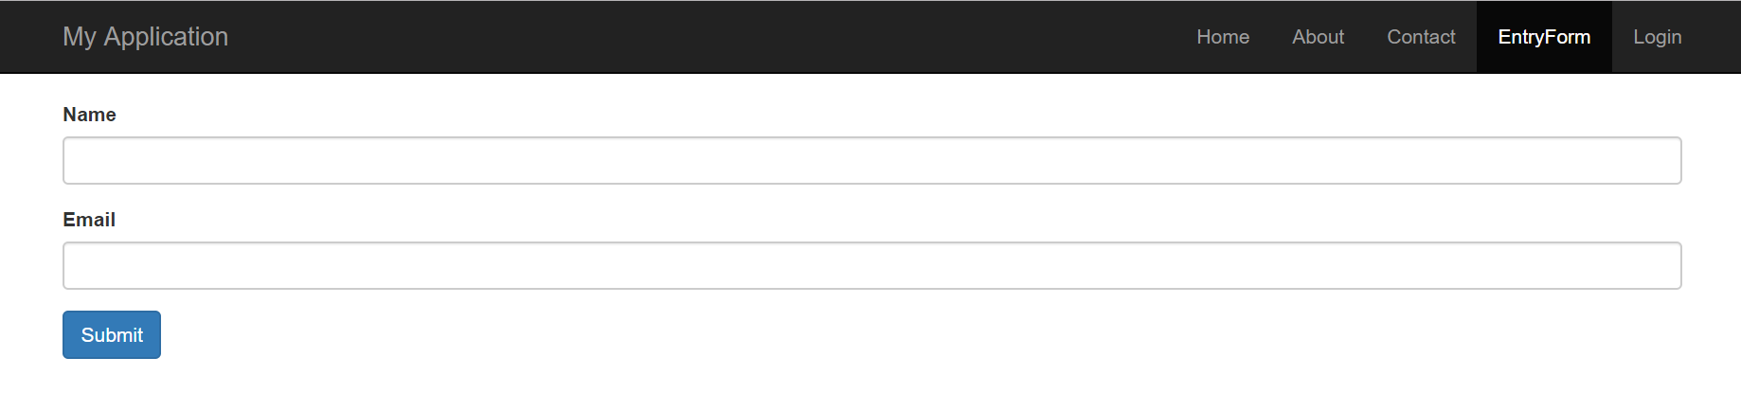

Output post submission:

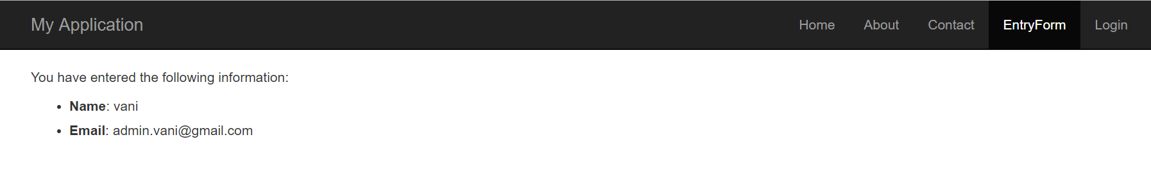

|  |  |  |  |  |  |
| --- | --- | --- | --- | --- | --- |
| ACCT640 | ACCT CON & PROCEDURE I | 3.00 |  | -----1 |  |
|  | ISTM622 | ADV DATA MANAGEMENT | 3.00 |  | -----1 |  |
|  | ISTM624 | ADV SYS ANLY & DESIGN | 3.00 |  | -----1 |  |
|  | ISTM630 | MIS PROJ MGMT AND IMPL | 3.00 |  | -----1 |  |
|  | ISTM631 | IS DESIGN & DEVELOP PROJ | 3.00 |  | -----1 |  |
|  | ISTM635 | BUS INFORMATION SECURITY | 3.00 |  | -----1 |  |
|  | ISTM637 | DATA WAREHOUSING | 3.00 |  | -----1 |  |
|  | ISTM643 | CORP INFO PLAN | 3.00 |  | -----1 |  |
|  | MGMT632 | TECH COMMERCIALIZATION | 3.00 |  | 202011 |  |
|  | STAT651 | STAT IN RESEARCH I | 3.00 |  | 201911 |  |
|  | STAT652 | STAT IN RESEARCH II | 3.00 |  | 201931 |  |
|  | STAT656 | APPLIED ANALYTICS | 3.00 |  | 201931 |  |